**EMFAC Data Extraction-User Manual**

Version: 1.0

Date: 18/5/2022

Written in Python 3.9.0

Library used:

* Python ==3.9.0
  + sqlite3
  + tkinter
  + itertools
* pandas==1.1.4
* numpy==1.19.4
* openpyxl==3.0.7
* XlsxWriter==3.0.1
* timebudget==0.7.1

Ensure all libraries are available to the script. GUI.exe would have included them already.

Written by: Wilson Pau

[Report Bugs Encountered](mailto:wilsoncwpau@meinhardt.com.hk)

**Brief Description**

The script consists of the following parts:

Input: Where informations including temperature, Relative Humidity, Vehicle Speed, Year of Study, Emission mode, Run mode is fed into the script.

Scripts: GUI.py is where all of the codes executes in a normal operation and exports the desired excel output file. Database.py creates the database for GUI.py from csv data files. Database_createindex.py is an optional script to be run once to optimize database such that queries can be about 5 times faster.

Generated Files: EMFAC_database.db acts as the database for GUI.py to extract data from. The output file is exported in excel format. Naming of the file will be determined by user input (year, run mode, emission mode).

Graphical explanation of the script is shown below.

Only performed when there is updated data

database.py

Data files

(nox, no2, pm2.5, pm10, pm30)

.csv

Step0  
tep

Step3  
tep

GUI.py

Temp, RH.xlsx

Vehicle Speed

User Input

Step1

Step2  
tep

Output

filename.xlsx

Determines filename  
tep

database_createindex.py

Optimization

**Procedure**

Run the GUI.exe (for users without python)/GUI.py

Python can be installed from <https://www.python.org/downloads/>

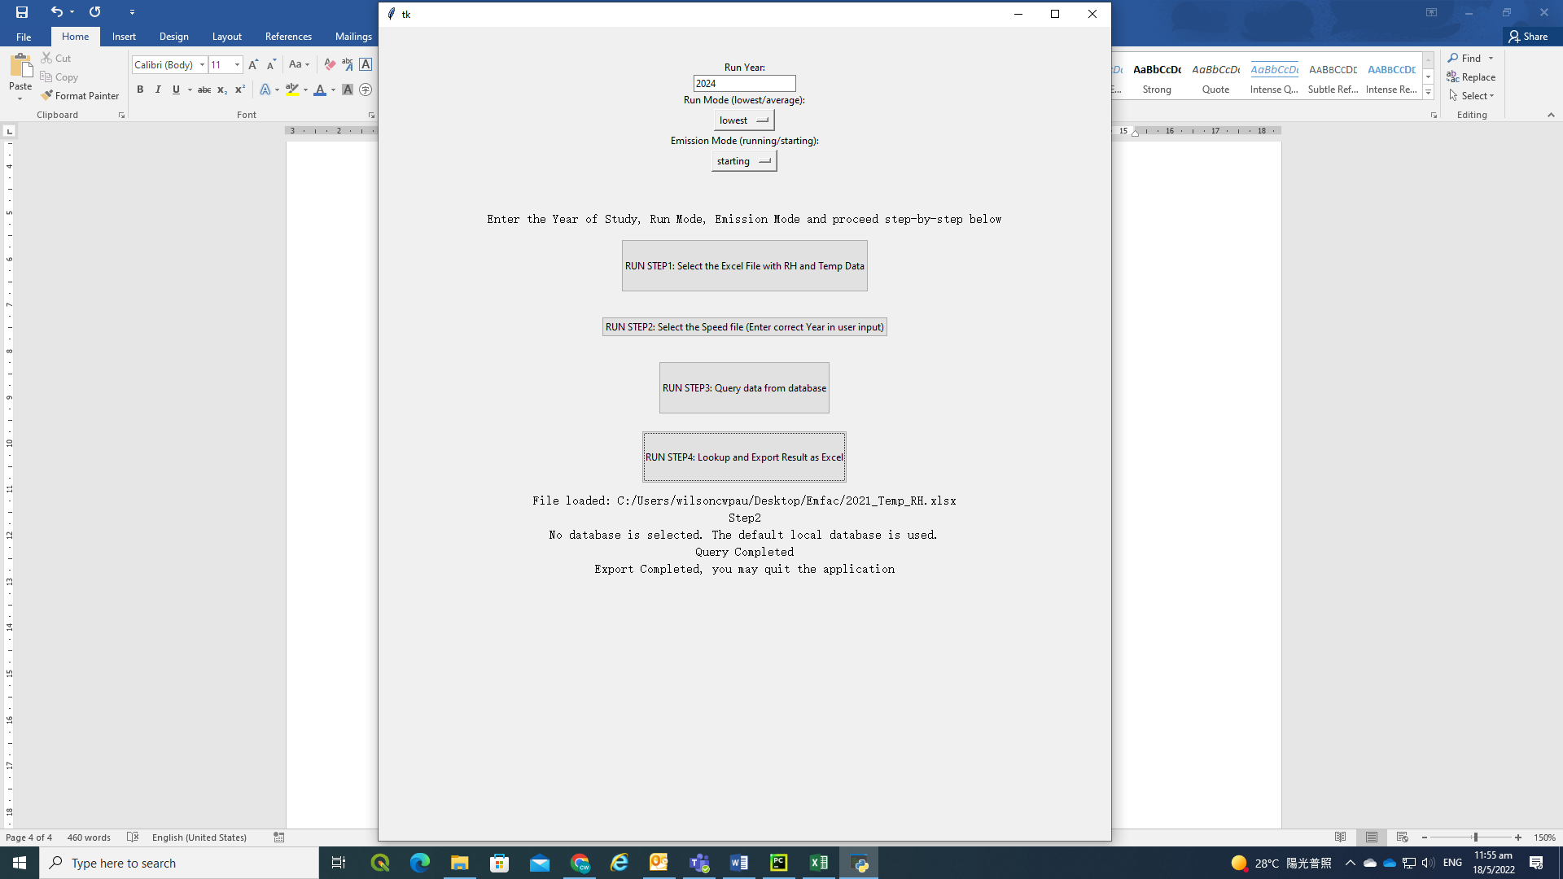

Step0: Manual User Input

* Enter a 4-digit study year (e.g. 2024)
* Select the correct Run mode (Lowest, Average)
* Select the correct emission mode (Running, Starting)

Step1: Import Temperature and Relative Humidity

* Click the Step 1 Button
* A file selection window will prompt
* Select the excel file containing Temperature, Relative Humidity (2021_Temp_RH.xlsx)
* Step completed when text “File loaded: {file location/2021_Temp_RH.xlsx }” appeared

Step2: Depending on Emission Mode (running/starting), import the Vehicle Speed/Time and create a list of combinations (Month, Hour, Temperature, Relative Humidity, Vehicle Speed/Time)

* Click the Step 2 Button
* If emission mode = running:
  + A file selection window will prompt
  + Select the excel file containing speed data; ensure worksheet naming as follows: Average speed ({yyyy}) where {yyyy} stands for study year inputted at step 0
* If emission mode = starting:
  + Step completed when text “Step2” appeared

Step3: The script “GUI.py” interacts with the database “EMFAC_database.db” to extract data

* Click the Step 3 Button
* A file selection window will prompt
* Select the target database (.db); if window is closed and no file is selected, the default database at local folder relative to GUI.py will be selected
* This step may take from 10s up to 5mins depending on PC performance and size of query
* Step completed when text “Query Completed” appeared

Step4: Process the extracted data and exports an excel file

* Click the Step 4 Button
* This step may take about 30s to 2min depending on data size
* Step completed when text “Export Completed, you may quit the application” appeared

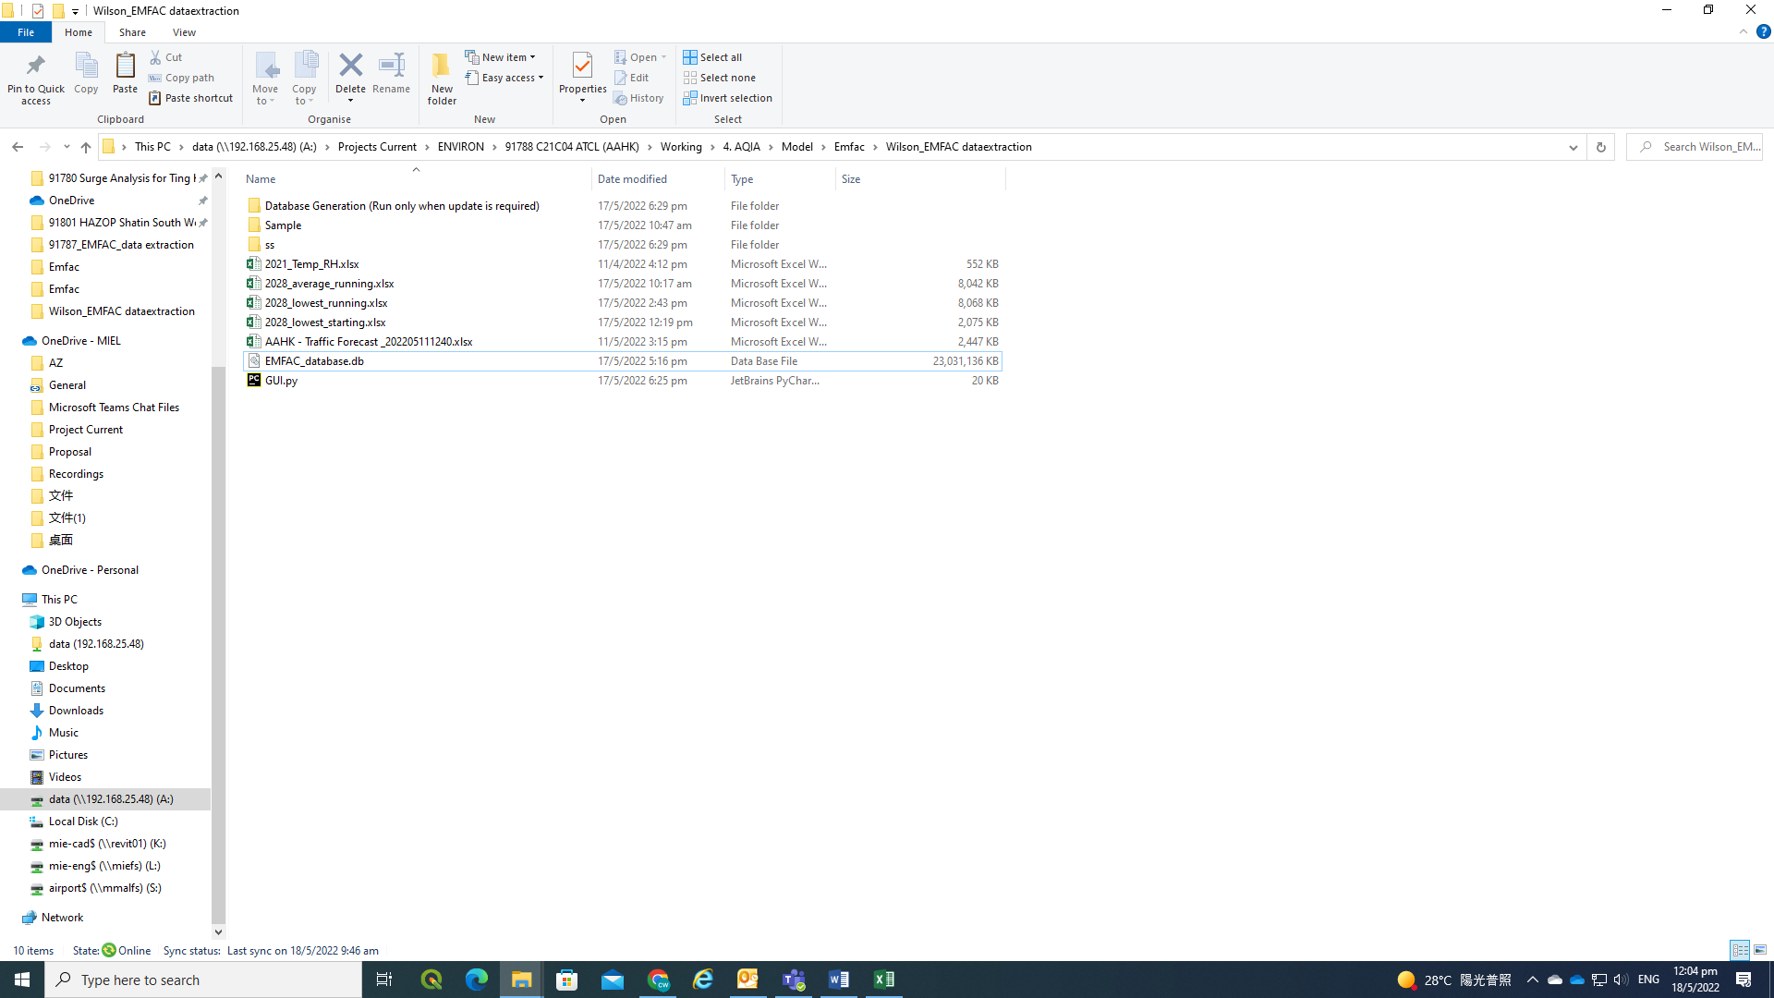

database

script

Temp, RH input

Output files

speed input

**Points to Note to avoid program crash:**

step1: ensure the sheet named ‘All’ is available and contains all the data with column name format is the same as shown in figure below.

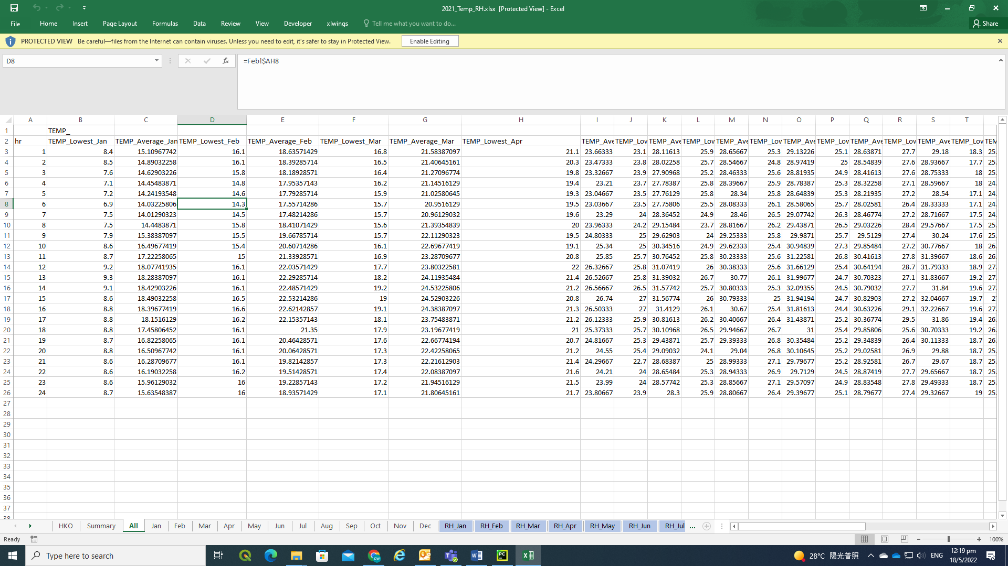

Step2: ensure the sheet named ‘Average Speed ({yyyy})’ is available and contains the speed data in columns F:AC in excel as shown in the figure below.

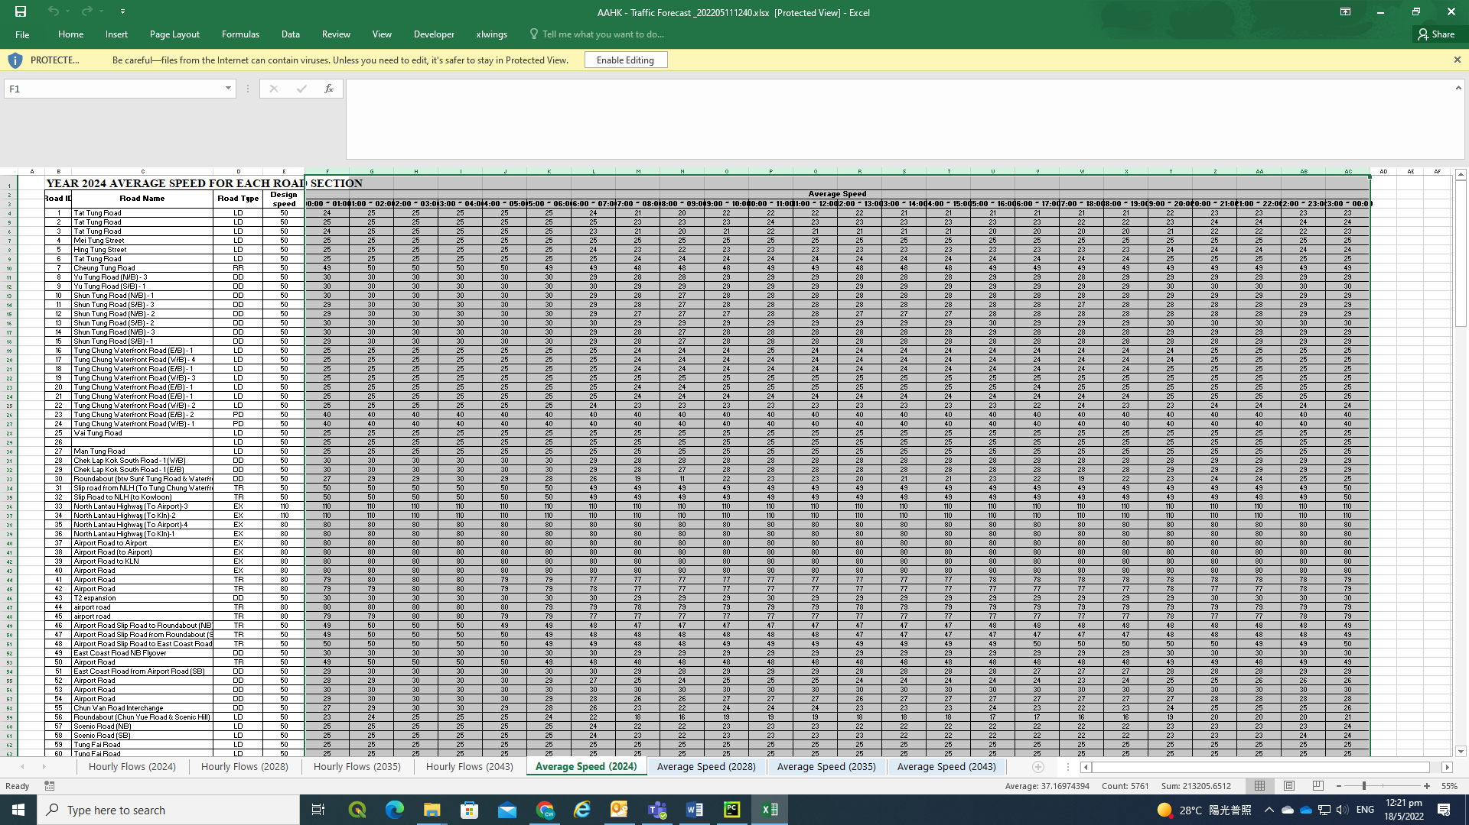

**Database**

Create Database

1. Run database.py/database.exe
2. A file selection window will prompt
3. Select and open ALL files

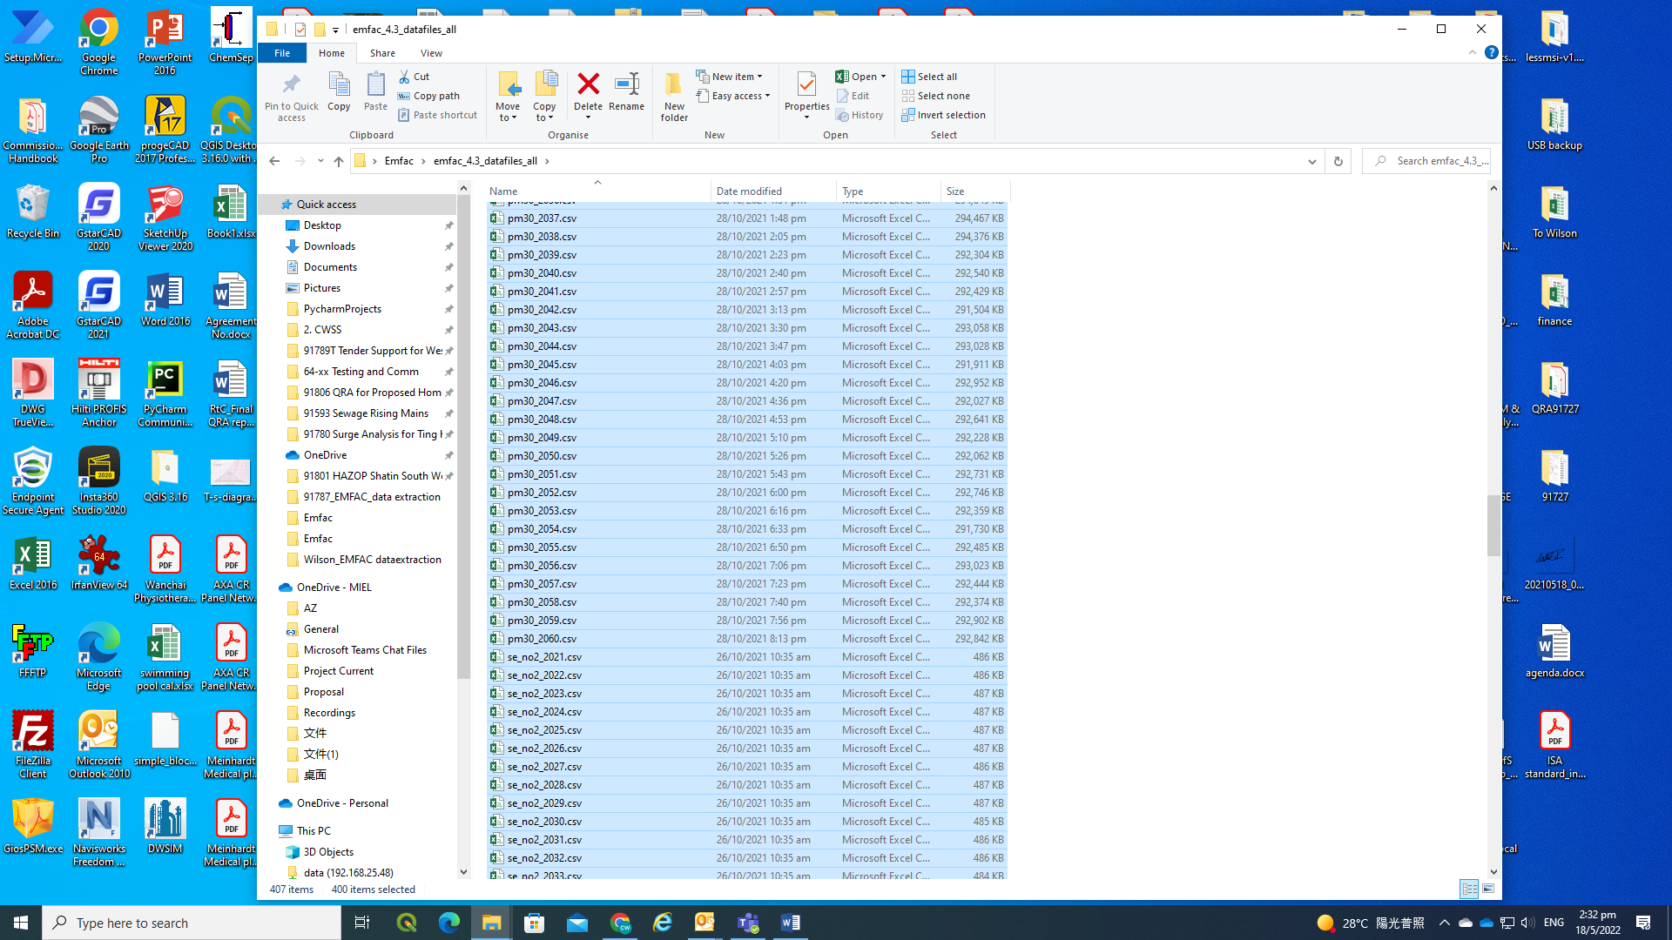

1. The process takes a relatively long time (~30-60mins)
2. A database EMFAC_database.db will be generated

(Optional) Create Database Index

After creating database, the database can be optimized for faster query, resulting in significantly lower running time for each run in GUI.py/GUI.exe.

1. Run database_create.py/database_create.exe
2. A file selection window will prompt
3. Select the target database EMFAC_database.db
4. The process takes a relatively long time (~5-30mins)
5. database EMFAC_database.db will be updated